Lab Sheet-12: Web Application using Servlet

In a college web portal, users must log in to access internal resources such as notices and profile information. For initial testing, the administrator wants to validate user credentials without using a database.
Design and implement a Java Servlet that:
• Accepts username and password from a login form,
• Validates the credentials using predefined (hardcoded) values, and
• Displays an appropriate success or failure message based on the login result.

Demonstrate the solution using a Servlet and an HTML login page.

1. Create an Eclipse Dynamic Web Project
To create a new dynamic Web project in Eclipse:
1. On the main menu select File > New > Project....
2. In the upcoming wizard choose Web > Dynamic Web Project.
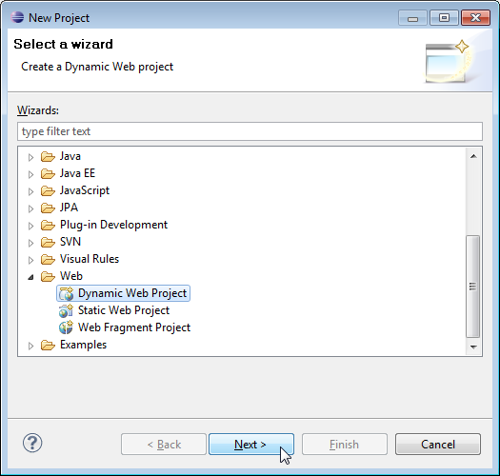

3. Click Next.
4. Enter project name as "Exp5";
5. Make sure that the target runtime is set to Apache Tomcat with the currently supported version.
index.html
<!DOCTYPE html>
<html>
<head>
<title>Login Page</title>
</head>
<body>
<h2>College Portal Login</h2>
<form action="insert" method="post">
Username: <input type="text" name="uname" required><br><br>
Password: <input type="password" name="pwd" required><br><br>
<input type="submit" value="Login">
</form>
</body>
</html>

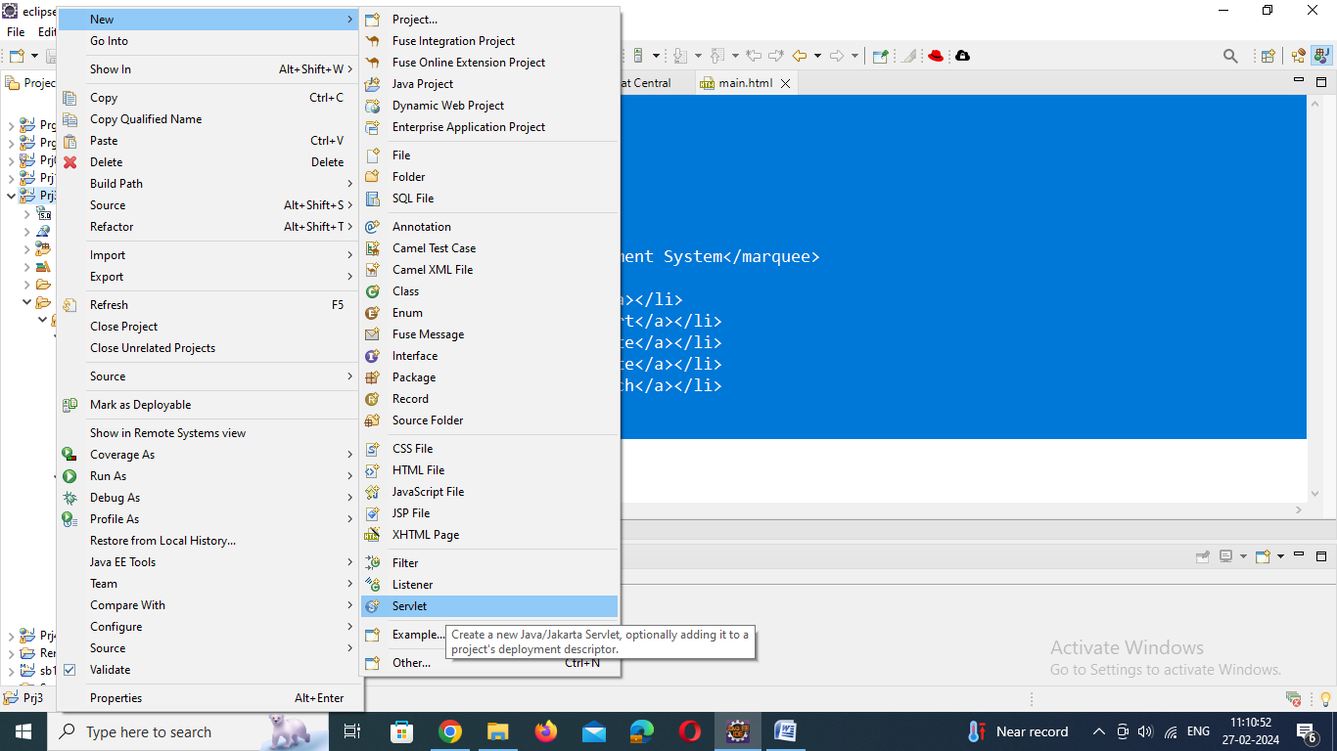

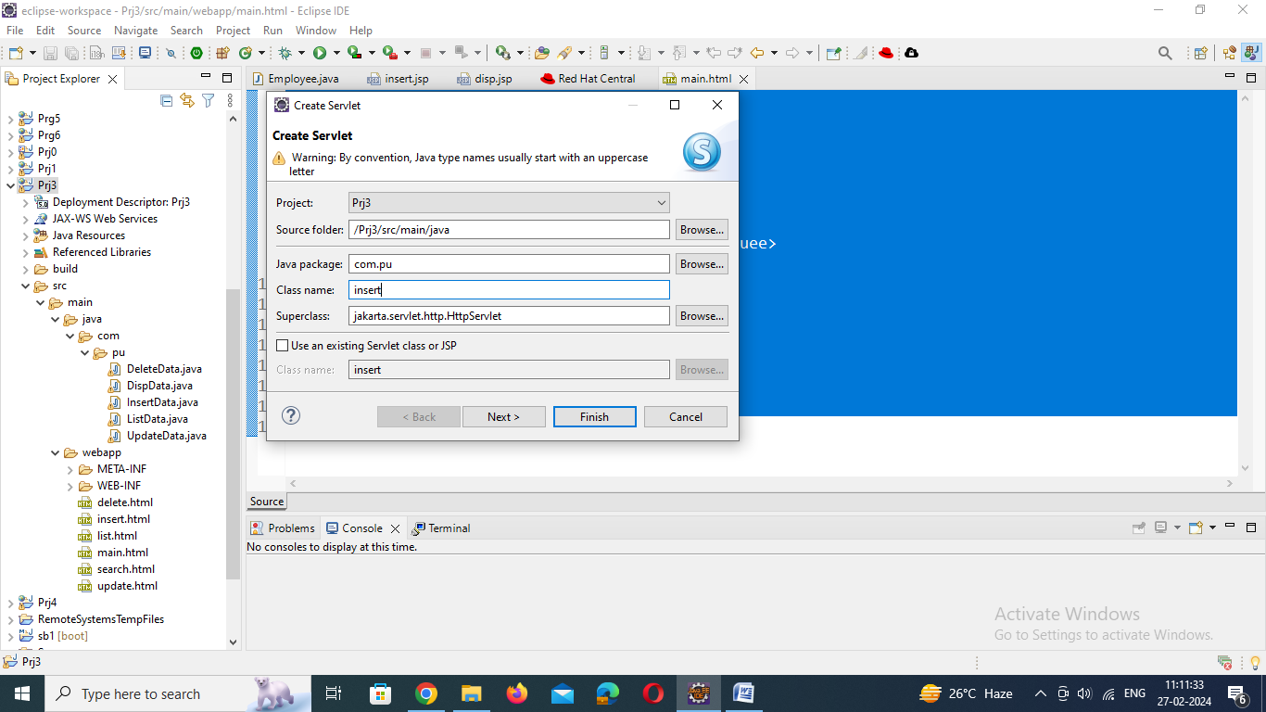

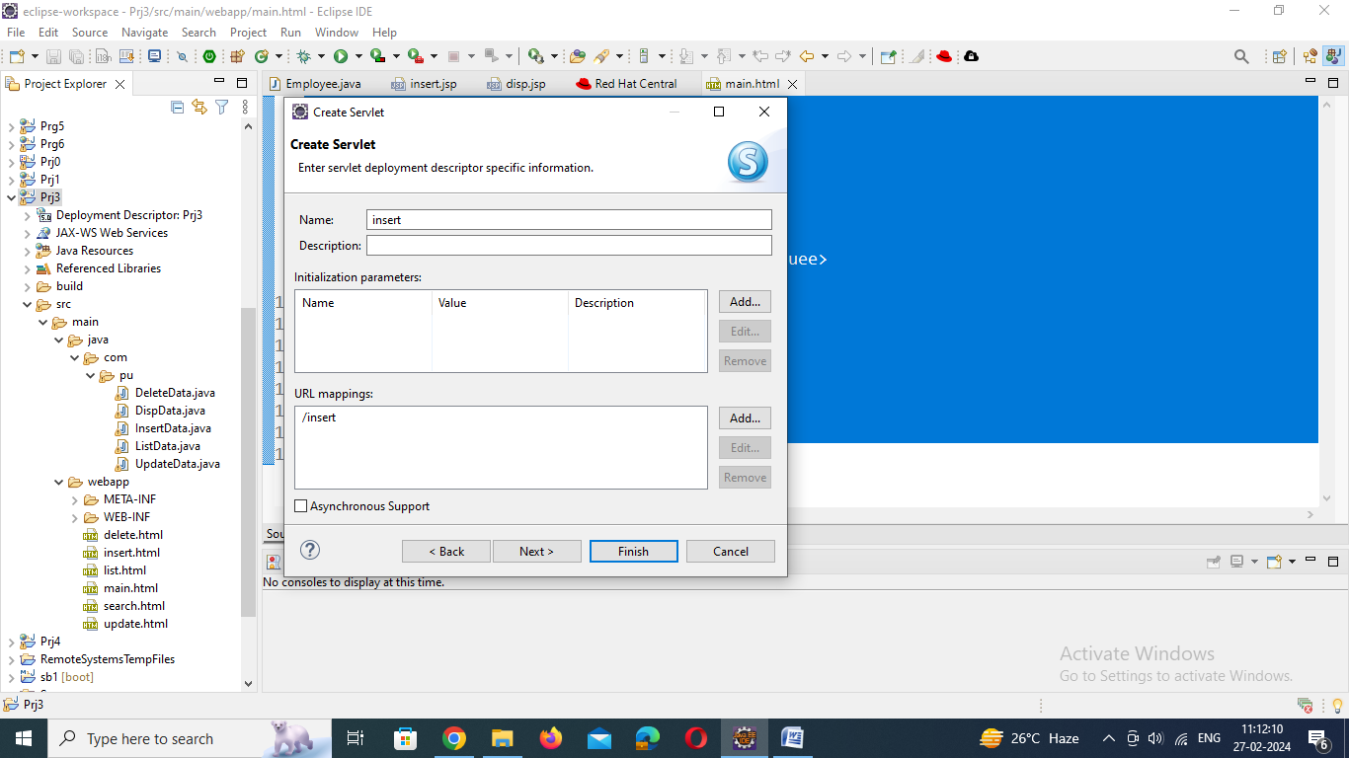

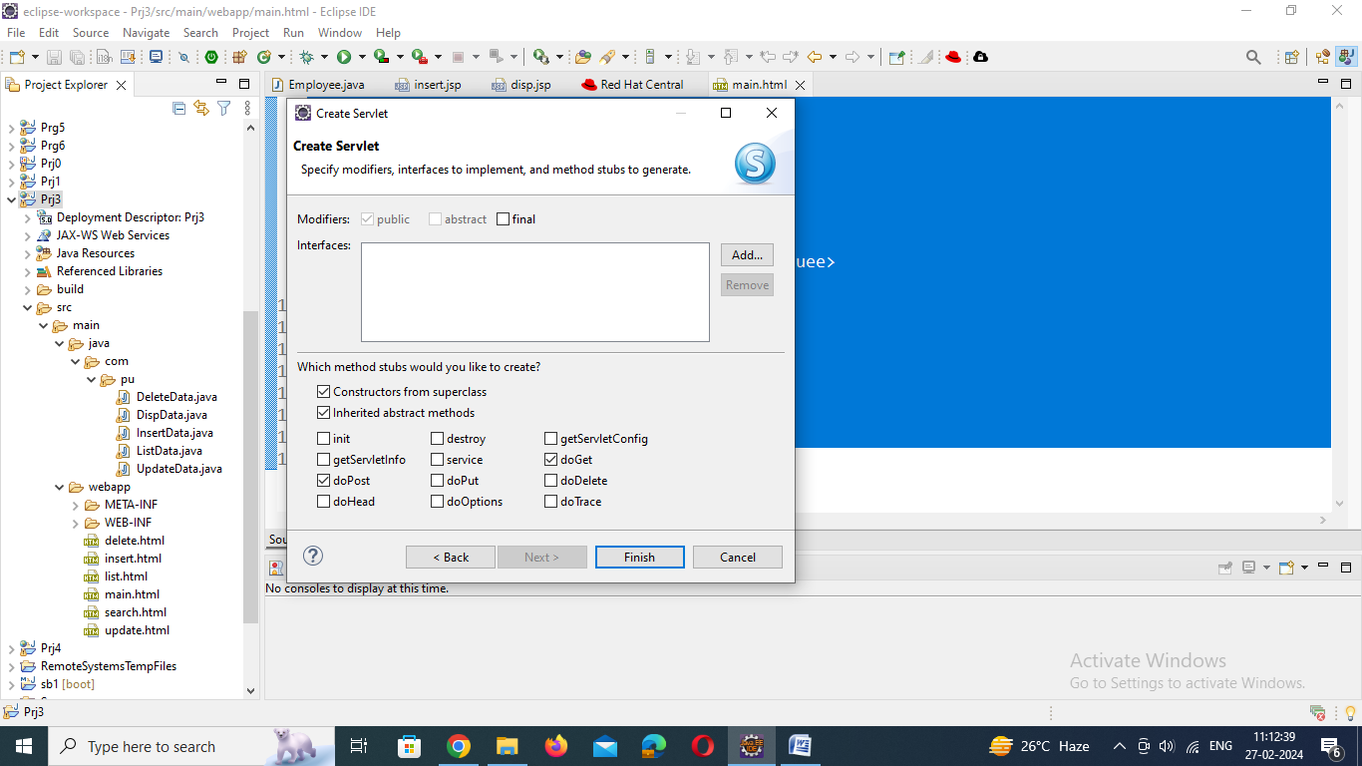

Insert.java

import java.io.IOException;
import java.io.PrintWriter;
import javax.servlet.ServletException;
import javax.servlet.annotation.WebServlet;
import javax.servlet.http.HttpServlet;
import javax.servlet.http.HttpServletRequest;
import javax.servlet.http.HttpServletResponse;
@WebServlet("/insert")
public class insert extends HttpServlet {
protected void doPost(HttpServletRequest request, HttpServletResponse response)
throws ServletException, IOException {
response.setContentType("text/html");
PrintWriter out = response.getWriter();
// Hardcoded credentials
String validUser = "admin";
String validPass = "12345";
// Getting values from HTML form
String user = request.getParameter("uname");
String pass = request.getParameter("pwd");
// Validation
if (user.equals(validUser) && pass.equals(validPass)) {
out.println("<h2>Login Successful!</h2>");
out.println("<p>Welcome to the College Web Portal.</p>");
} else {
out.println("<h2>Login Failed!</h2>");
out.println("<p>Invalid username or password. Try Again.</p>");
}
}
}

